EXPT NO:4B | EXPLORATORY DATA ANALYSIS-DATA INSPECTION, FILTERING, STATISTICAL ANALYSIS AND CORRELATION

AIM:
To visualize the Student Performance dataset using Python and create different charts to understand student academic performance and identify important patterns.
PROCEDURE:
- Start the program.
- Import Pandas, NumPy, Matplotlib, and Seaborn libraries.
- Load the Student Performance Factors CSV dataset using Pandas.
- Display the first few records using head().
- Display the dataset shape, column names, and data types.
- Select important numerical columns such as Hours_Studied, Attendance, Previous_Scores, Sleep_Hours, Tutoring_Sessions, and Exam_Score.
- Filter the dataset based on suitable conditions such as students with high attendance and high examination scores.
- Calculate statistical measures such as mean, median, minimum, maximum, and standard deviation.
- Analyze the average examination score based on gender and parental education level.
- Create suitable graphs such as bar charts, histograms, and scatter plots.
- Calculate the correlation between numerical variables.
- Generate a correlation heatmap to identify relationships between different student performance factors.
- Interpret the results and identify important patterns.
- Stop the program.

CODE:
import pandas as pd
import numpy as np
import matplotlib.pyplot as plt
import seaborn as sns

# 1. Load Dataset
df= pd.read_csv("StudentPerformanceFactors.csv")

# 2. Display First Few Records
print("First 5 Records:")
print(df.head())

# 3. Dataset Information
print("\nDataset Shape:")
print(df.shape)
print("\nColumn Names:")
print(df.columns.tolist())
print("\nData Types:")
print(df.dtypes)

# 4. Select Numerical Columns
num_cols = df.select_dtypes(include=np.number).columns
print("\nNumerical Columns:")
print(num_cols.tolist())

# 5. Statistical Analysis
print("\nStatistical Summary:")
print(df[num_cols].describe())

# 6. Mean, Median and Standard Deviation
print("\nMean Values:")
print(df[num_cols].mean())
print("\nMedian Values:")
print(df[num_cols].median())
print("\nStandard Deviation:")
print(df[num_cols].std())

# 7. Filtering Students
high_attendance = df[df["Attendance"] >= 90]
print("\nStudents with Attendance >= 90:")
print(high_attendance.head())
print("\nNumber of Students with Attendance >= 90:")
print(len(high_attendance))

# 8. Filtering High Performers
high_performers = df[df["Exam_Score"] >= 70]
print("\nHigh Performing Students:")
print(high_performers.head())
print("\nNumber of High Performing Students:")
print(len(high_performers))

# 9. Average Exam Score by Gender
gender_analysis = df.groupby("Gender")["Exam_Score"].mean()
print("\nAverage Exam Score by Gender:")
print(gender_analysis)

# 10. Average Exam Score by
education_analysis = df.groupby(
"Parental_Education_Level"
)["Exam_Score"].mean()
print("\nAverage Exam Score by Parental Education Level:")
print(education_analysis)

# 11. BAR CHART
plt.figure(figsize=(8, 5))
sns.barplot(
data=df,
x="Gender",
y="Exam_Score",
estimator="mean"
)
plt.title("Average Exam Score by Gender")
plt.xlabel("Gender")
plt.ylabel("Average Exam Score")
plt.show()

# 12. HISTOGRAM
plt.figure(figsize=(8, 5))
sns.histplot(
df["Exam_Score"],
bins=20,
kde=True
)
plt.title("Distribution of Exam Scores")
plt.xlabel("Exam Score")
plt.ylabel("Number of Students")
plt.show()

# 13. SCATTER PLOT
plt.figure(figsize=(8, 5))
sns.scatterplot(
data=df,
x="Hours_Studied",
y="Exam_Score"
)
plt.title("Hours Studied vs Exam Score")
plt.xlabel("Hours Studied")
plt.ylabel("Exam Score")
plt.show()

# 14. SCATTER PLOT
plt.figure(figsize=(8, 5))
sns.scatterplot(
data=df,
x="Attendance",
y="Exam_Score"
)
plt.title("Attendance vs Exam Score")
plt.xlabel("Attendance")
plt.ylabel("Exam Score")
plt.show()

# 15. CORRELATION MATRIX
correlation = df[num_cols].corr()
print("\nCorrelation Matrix:")
print(correlation)

# 16. CORRELATION HEATMAP
plt.figure(figsize=(12, 8))
sns.heatmap(
correlation,
annot=True,
cmap="coolwarm",
fmt=".2f"
)
plt.title("Correlation Heatmap - Student Performance Factors")
plt.show()

# 17. Final Result
print("\nEDA Data Inspection, Filtering,")
print("Statistical Analysis and Correlation")
print("Completed Successfully!")

OUTPUT:

First 5 Records:
Hours_Studied Attendance Parental_Involvement Access_to_Resources
0 23 84 Low High
1 19 64 Low Medium
2 24 98 Medium Medium
3 29 89 Low Medium
4 19 92 Medium Medium

Extracurricular_Activities Sleep_Hours Previous_Scores Motivation_Level
0 No 7 73 Low
1 No 8 59 Low
2 Yes 7 91 Medium
3 Yes 8 98 Medium
4 Yes 6 65 Medium

Internet_Access Tutoring_Sessions Family_Income Teacher_Quality
0 Yes 0 Low Medium
1 Yes 2 Medium Medium
2 Yes 2 Medium Medium
3 Yes 1 Medium Medium
4 Yes 3 Medium High

School_Type Peer_Influence Physical_Activity Learning_Disabilities
0 Public Positive 3 No
1 Public Negative 4 No
2 Public Neutral 4 No
3 Public Negative 4 No
4 Public Neutral 4 No

Parental_Education_Level Distance_from_Home Gender Exam_Score
0 High School Near Male 67
1 College Moderate Female 61
2 Postgraduate Near Male 74
3 High School Moderate Male 71
4 College Near Female 70
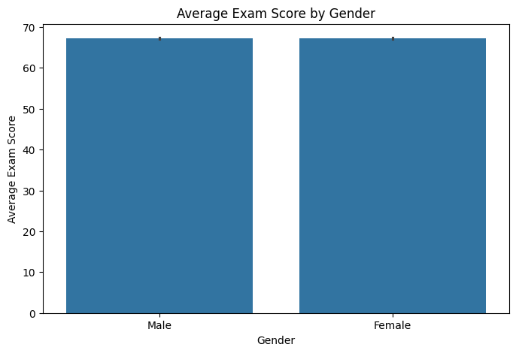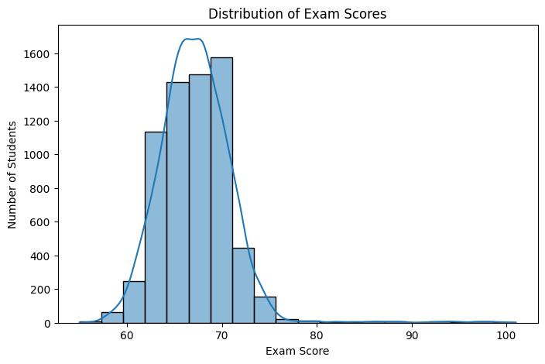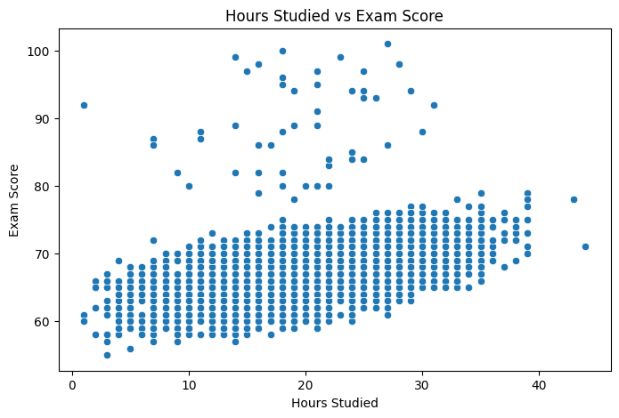

Result:

